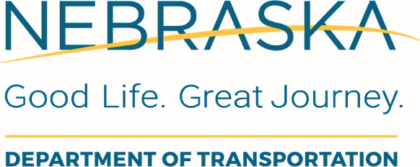
Re-Evaluation Form
Project Development Division

Project Name: | Project No.: |  | Control No.:
Project Location:

NEPA Documentation Level: |  | Original NEPA Approval Date:
Date of This Re-evaluation: |  | Date of Prior Re-evaluation(s):

Reason for the Re-evaluation (check all that apply):

☐ Project scope changes
☐ New, or changes to, project impacts
☐ New or updated circumstances
☐ Project is proceeding to the next major federal approval:
☐ Final design ☐ Right-of-way acquisition ☐ PS&E approval
☐ Project exceeds the 3-year timeframe for an EIS

Describe the changes requiring the re-evaluation:

Need for Resource Review (complete this section ONLY if changes require the re-evaluation):

☐ A NEPA Author has reviewed this project and has determined, due to the minor scope of the changes, that additional environmental resource review is not required.

☐ A NEPA Author has reviewed this project and has determined that additional review of the following resources is warranted:

Evaluation of Resource Impacts (complete this section ONLY if changes require the re-evaluation)

Present the evaluation of, and results for, each resource impact requiring discussion below.

Evaluation of Mitigation (complete this section ONLY if changes require the re-evaluation)

☐ All of the original mitigation measures apply with no modification.

☐ The following mitigation measures have been revised, added, or removed:

A complete list of current mitigation measures, including modifications with this re-evaluation, is provided below:

Re-evaluation Conclusion

☐ With the information provided in this re-evaluation form, the original project NEPA documentation remains valid.

☐ The original project NEPA documentation is no longer valid.
☐ Supplemental environmental documentation is needed.
☐ New environmental documentation is needed. Specify class of action:

Re-evaluation Approval

NEPA Author:

Prepared by – PLEASE PRINT Signature Date

Organization and Title

Phone Email

NDOT Approver:

Approved by – PLEASE PRINT Signature Date

Title

The environmental review, consultation, and other actions required by applicable Federal environmental laws for this project are being, or have been, carried out by NDOT pursuant to either 23 U.S.C. 326 and a Second Renewed Memorandum of Understanding dated September 12, 2024 executed by FHWA and NDOT or pursuant to 23 U.S.C. 327 and a Memorandum of Understanding dated February 23, 2026 and executed by FHWA and NDOT, as applicable.

