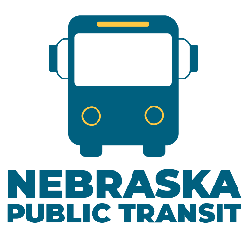

EXISTING SUBRECIPIENT 5310 PROGRAM APPLICANT
APPLICATION CHECKLIST

Instructions:

- Review FTA Section 5310 Program Guidelines as a refresher of the program
- Ensure all current vehicle reports are up to date in Transit Manager Portal
- Download Application from Website to complete
- Draft and send in public notice for application of federal funds to be published
- Attain a copy of the Articles of Incorporation (non-profits only)
- Get a resolution from non-profit Governing Board approving application
- Submit application with all attachments into the Transit Manager Portal by October 31.

Ensure completion of the following as the review committee will confirm:

- Include an active UEI from SAM.gov
- Confirm non-profit organization status
  - If Governmental, contact Carly Grutel at 402-479-3185 or carly.grutel@nebraska.gov;
- Maintenance Certification is signed with title listed and dated
- The full application is complete and signed with title listed and dated
- Articles of Incorporation (non-profits only)
- Affidavit of proof of public notice published in newspaper
- Resolution from Governing Board approving application with an authorizing person to sign documents on behalf of corporation. The resolution must reference the 5310 Program.

