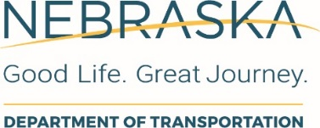
RFQ-2326
Project Interest Form

Prime Consultant:
Sub-Consultant:
Sub-Consultant:
Sub-Consultant:
Sub-Consultant:

# | Projects | Interest
 |  | Yes | No
1 | CN12046, NH-180-9(733), Hwy 6 & Adams St Bridges over I-180
2 | CN 13472, NH-180-9(8) I-180 Bridges over I-80
3 | CN 13487, NH-75-1(110), US-75, Kansas State Line-Auburn
4 | CN 32393, NH-81-4(129), N-59 - N-84
5 | CN 42944, NH-34-4(136), Doniphan to I-80
6 | CN 42945, STP-14-1(125), Nelson North
7 | CN 61726, NH-80-4(161), Maxwell - Brady
8 | CN 81137, NH-20-2(155), Thatcher - Arabia

