 |  | Contractor Site Use Request  Identification and Evaluation
Project No.:
Control No(s).:
Project Name:
County(s):

NOTE: This form is to be used for all Borrow/Plant/Stockpile/Waste and Construction Debris Site Requests. Site Requests will not be forwarded for Agency Review until all request requirements have been fulfilled by the Requestor. To avoid delay, please provide complete, clear and concise documentation and photographs.

Site Location and Ownership
1. Identify the precise location of the site (to the nearest 2½ acres)
 |  | ¼, of |  | ¼, of Section |  | T- |  | -N, | R- |  | –
a. Attach a color aerial photo precisely depicting the site location, exact site boundaries, and haul roads.
b. Attach color photographs, taken from the corners of the site inward that provide an accurate depiction of existing site characteristics (minimum of 4).

2. Name of Owner:
a. Address:
b. Phone No.:
c. Email Address:
Site Requestor
3. Requesting Contractor:
a. Address:
b. Contact Person:
c. Phone No.:
d. Email Address:
4. This site will be used for (Check all that apply): Borrow Plant Stockpile Waste
Construction Debris
Explanation:
5. To your knowledge, has this site been previously used as a Borrow, Plant, Stockpile, Waste, or Construction Debris Site?
Yes No Unknown
NDOT Form 119, July 2022
7. This site is currently used for:
Commercial Material Site Borrow Agriculture Irrigation Recharge Pit
Stockpiled Materials Pasture Stock Pond Urban/Suburban Residential
Other (explain):
Explanation:
8. Vegetation cover (if applicable) is:
Grass | Type:
Trees | Type:
Weeds | Type:
Crops | Type:
None | Type:
Other (explain)
Explanation:

9. Will any trees be removed that are 3 inches or greater diameter @ breast height (48 inches above ground level)? Yes No

10. Does this site currently pond water? Yes No
a. If Yes, give existing surface area of water: |  | Acre

11. Will this site pond water when completed?
No This site will be graded to prevent storage of surface water.
Acre- Feet
Yes (If Yes, how many acre-feet will be exposed?)

12. Is this site within the Platte River System? Yes No
Refer to the attached Platte River System Reference Map

a. Will the site detain water in excess of 72 hours? Yes No

13. Is this site within American Bury Beetle (ABB) Habitat range ?
(Refer to attached ABB Map)

No This site is not located within the range of ABB

Yes (If Yes, fill out the ABB Avoidance and Minimization Questions below)

SUBMIT TO:
Nebraska Department of Transportation ● Environmental Section ATTN: RDCU ● PO Box 94759
Lincoln NE 68509-4759 ● Email: ndot.mssrequest@nebraska.gov

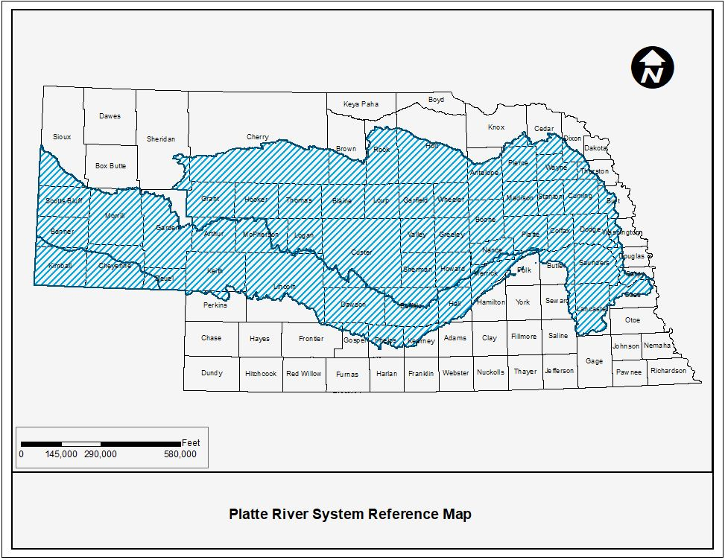

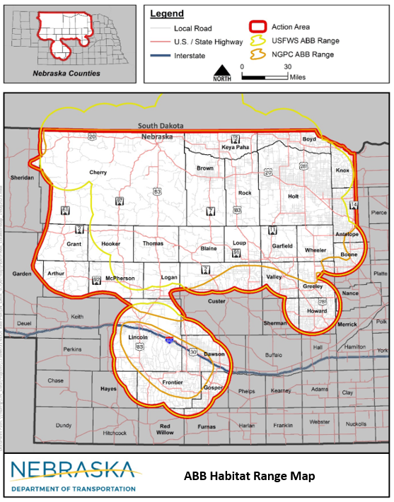

Supplemental American Burying Beatle Avoidance and Minimization Questions
Avoidance-
- Were you able to find a Contractor Use Site previously approved by NDOT within 5 miles of the project alignment?
  - ☐ YES or ☐ NO (If yes, see below)
  - If you checked yes above, are the limits of disturbance of the site being expanded?
  - ☐ YES or ☐ NO
- Were you able to find a site in unsuitable habitat within 5 miles of the project? (If no, please give a brief statement why no sites were chosen)
  - ☐ YES or ☐ NO

- Were you able to find a site in suitable habitat within 5 miles of the project limits? (If yes, please give a brief 2-3 sentence statement of why this site was chosen)
  - ☐ YES or ☐ NO

Minimization-
- Has this area been previously used before as a contractor use site?
  - ☐ YES or ☐ NO
- Do you have a site plan developed to minimize the footprint of disturbance as much as possible?
  - ☐ YES or ☐ NO
- Will the contractor follow all Avoidance and Minimization Measures followed in the American Burying Beetle Programmatic Biological Assessment?
  - ☐ YES or ☐ NO

