Call to Order

Roll Call

Minutes – Approval of December 12, 2025 meeting minutes

Introductions/Announcements

Director's Remarks
Vicki Kramer, NDOT Director

Old Business

- Highway Naming
  - Nebraska Medal of Honor Highway
  - Hollis D. Stabler Application
Matt Neemann, NDOT Traffic Engineer

New Business

- Winter Operations Update
Ben Merchant, Assistant Operations Division Manager

- Legislative Update
Ryan Balluck, NDOT Government Affairs Manager

- Proposed 2026 Highway Commission Meetings Calendar
Marissa Kuehn, Highway Programs Administrator

- Election of 2026 Commission Chair & Vice Chair
Marissa Kuehn, Highway Programs Administrator
Public Input

Remarks from the Chair

Public Meetings Calendar

Adjournment

Nebraska State Highway Commission meetings are conducted in compliance with the Nebraska Open Meetings Act.

January 16, 2026
8:30 a.m.

NDOT Central Headquarters
Auditorium
1500 Nebraska Parkway
Lincoln, Nebraska

Virtual Option:
An audio feed will be available
by dialing 1-408-418-9388.
When prompted, enter
meeting number:
2488 271 9910 to
connect to the call.

If attendees would prefer an
access link for computer or
mobile viewing, visit https://ndot.info/JANUARY26HCM to join the meeting via WebEx and enter 2488 271 9910 (NDOT2026 from phones and video systems) when prompted.

Please contact Marissa Kuehn at 402-479-4514 or Marissa.Kuehn@nebraska.gov

Nebraska Department of Transportation
1500 Nebraska Parkway Lincoln, NE 68502 402-471-4567

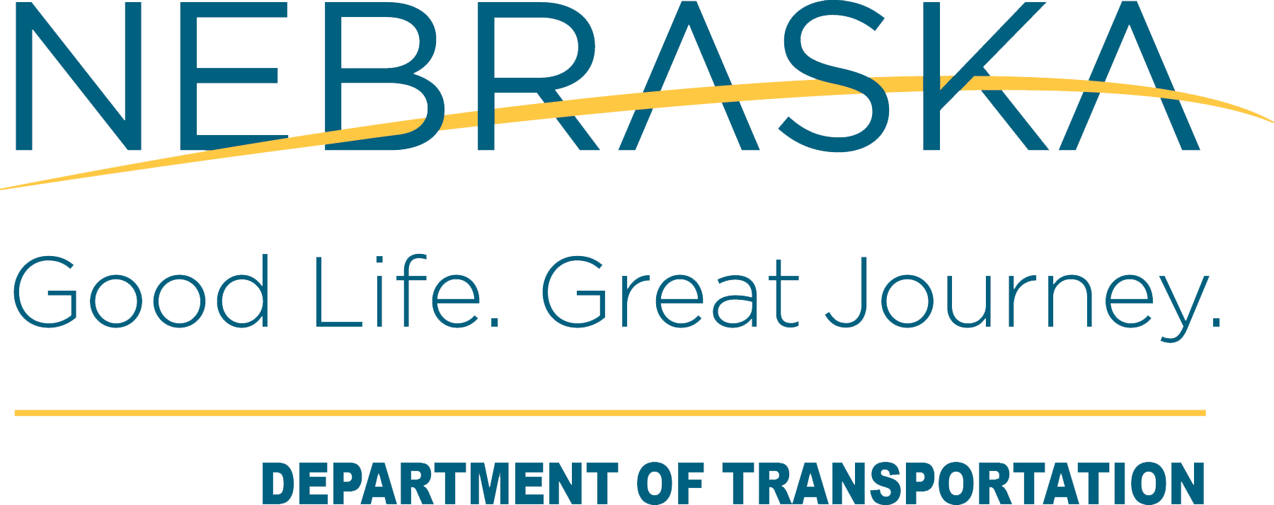
Nebraska State Highway Commission Agenda

