NEBRASKA DEPARTMENT OF TRANSPORTATION
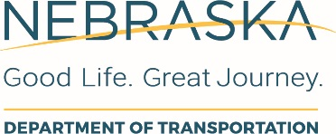
REQUIRED ELECTRONIC SIGNATURE AUTHORIZATION FORM
FIRM: | Type Firm’s name here |  | SUBMITTED BY: |  | Name |  | DATE SUBMITTED: |  | Select date here
AGREEMENT TYPES |  | NAMES OF AUTHORIZED SIGNERS | TITLE | TELEPHONE |  | EMAIL | NAMES OF OTHERS TO BE COPIED | EMAIL
Ex. Bridge / Roadway / Environmental / All / Other (explain) |  | Name | Director | 555.555.5555 |  | name@firm.com | Name | name@firm.com
The submitter must send this list to: Nebraska Department of Transportation, Project Development, Agreements Section, P.O. Box 94759, Lincoln, Nebraska 68509-4759, or via email to NDOT.PDAnnualCertification@nebraska.gov. The Nebraska Department of Transportation (NDOT) will not accept electronic signatures from anyone not identified on this list by the submitter as an authorized signer for the firm. The submitter is responsible for updating this list immediately in the event that an individual identified herein is no longer authorized to sign agreements. This form will be also be used by NDOT to determine who will get copies of the agreement through the DocuSign® process. Consultant shall disclose, using this form, who is presently authorized by Consultant to sign agreements with NDOT, and who should receive copies of the agreements after the signing process is complete.

